LAB ACTION PLAN FOR WEEK 5
Docker:
Docker is an open-source platform that automates the process of building, packaging, and running applications inside lightweight, portable containers, ensuring they run consistently across different environments.
Docker Images:
A read-only template that contains the application code, runtime, libraries, and dependencies. It is like a blueprint for creating containers.
Docker Containers:
A running instance of a Docker image.
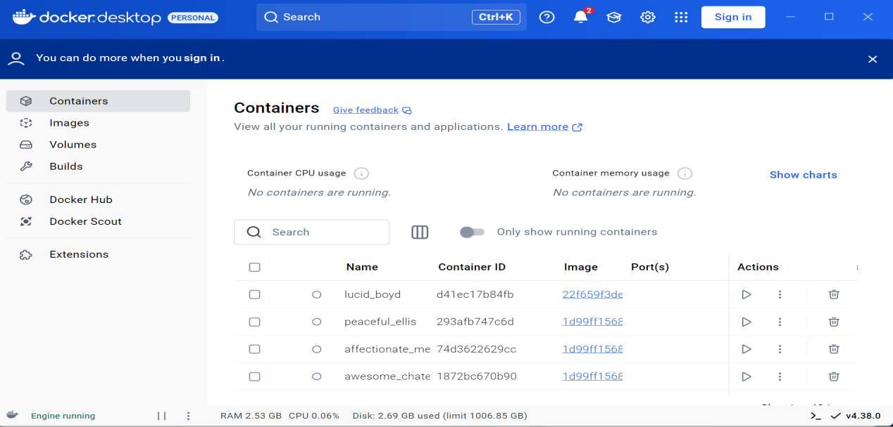
Working with Docker CLI Commands:
Docker CLI Commands with redis
Step 1: Pull the redis Image
Command:
docker pull redis
Step 2: Run a Redis Container
Command:
docker run --name my-redis -d redis

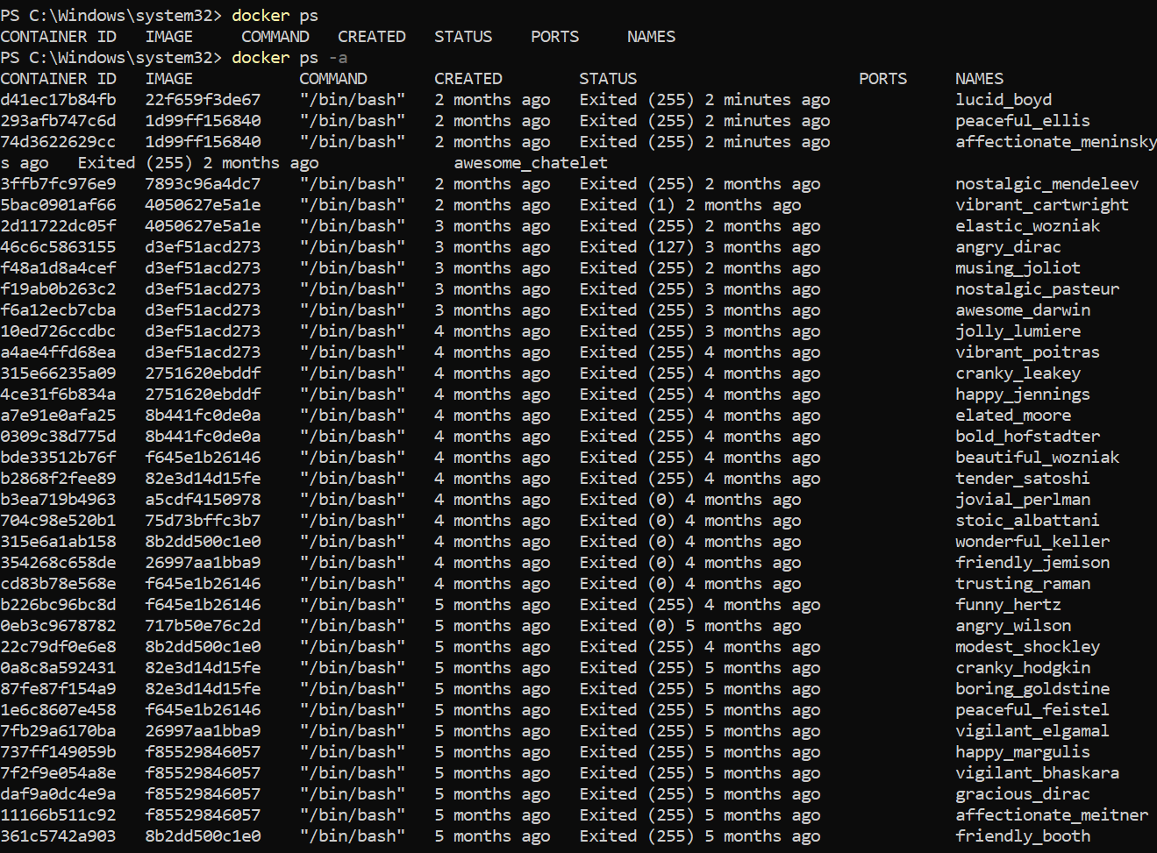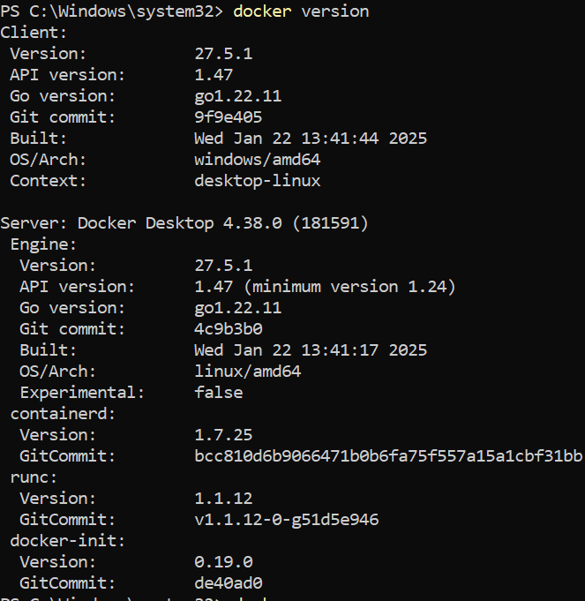

What It Does:
• Creates and starts a container named my-redis from the redis image.
• The -d flag runs the container in the background.
Step 3: Check Running Containers
Command:
docker ps

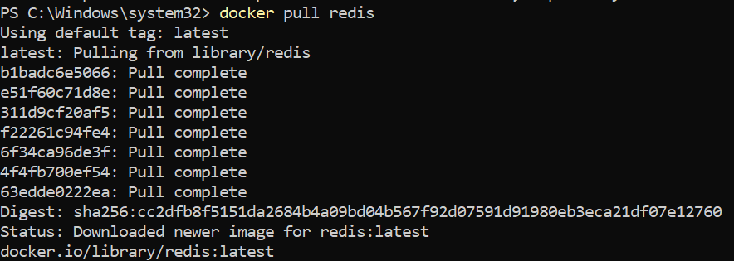

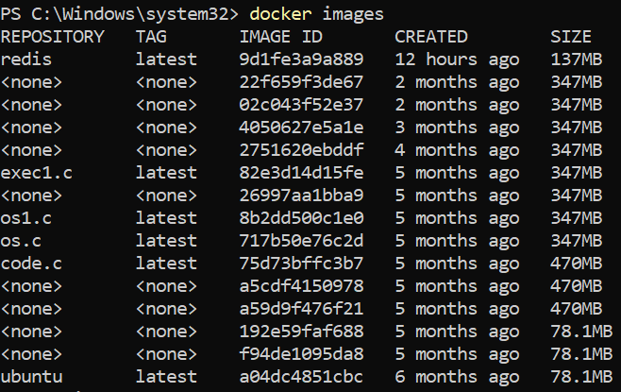
Step 4: Access Redis
Command:
docker exec -it my-redis redis-cli
Opens the Redis command-line tool (redis-cli) inside the container.
Example Redis Commands:
127.0.0.1:6379> SET name "Alice"
OK
127.0.0.1:6379> GET name
"Alice"

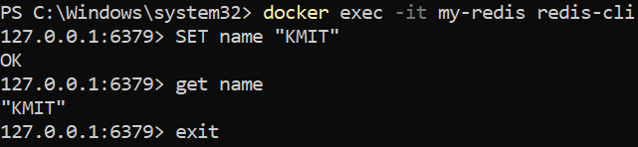
Step 5: Stop the Redis Container
Command:
docker stop my-redis

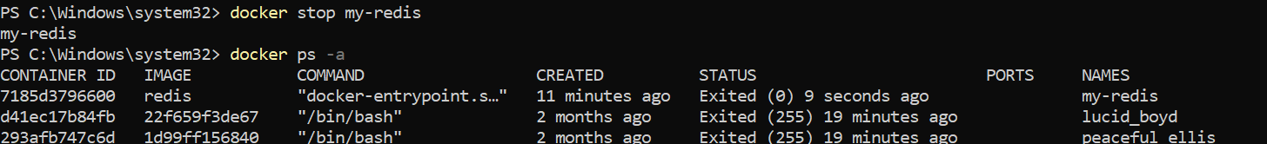

Step 6: Restart the Redis Container
Command:
docker start my-redis
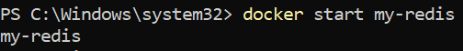

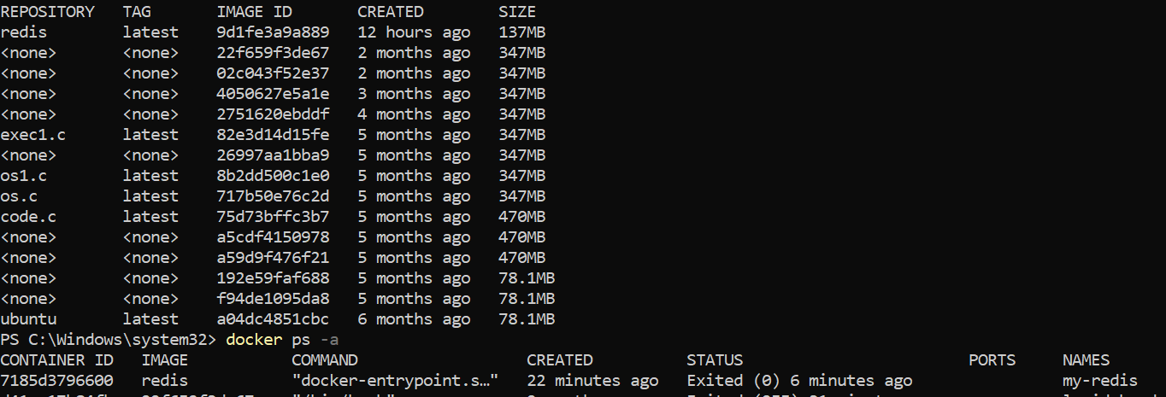
Step 7: Remove the Redis Container
Command:
docker rm my-redis
What It Does:
• Deletes the container permanently.
What It Does:
• Deletes the Redis image from your local system.

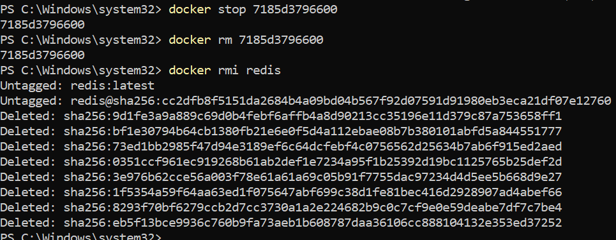

2.Working with Docker file
A Docker file is a text file with instructions to create a custom Docker image.
Step 1: Set Up Your Folder
1. Windows:
o Create a folder like C:\DockerProjects\Redis.
o Open Git Bash and navigate to the folder:
cd /c/DockerProjects/Redis
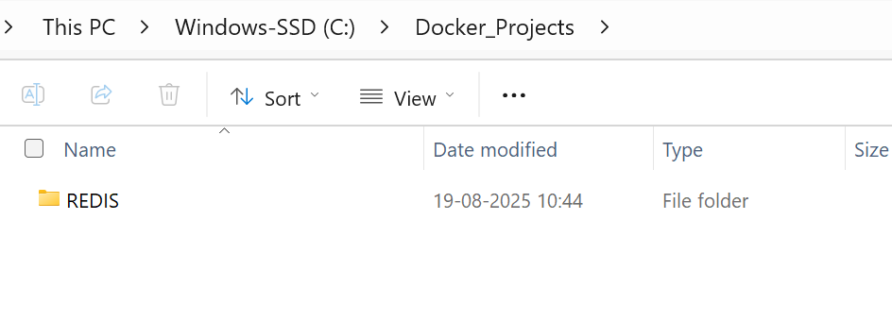
2. Mac/Linux:
o Create a folder:
mkdir ~/DockerProjects/Redis
cd ~/DockerProjects/Redis
Step 2: Write the Dockerfile
1. Inside the folder, create a file named Dockerfile (no extension).
2. Add the following content:
FROM redis:latest
CMD ["redis-server"]
Docker Commands (Step-by-step):

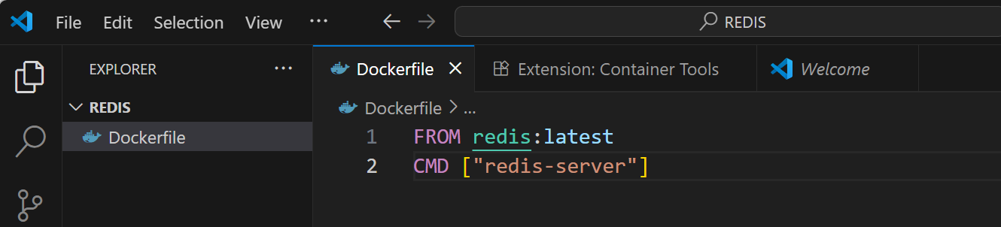

1. docker build -t redisnew .
What it does:
• This creates (builds) a Docker image using the recipe (Dockerfile) in the current
folder (.).
• -t redisnew: Gives the image a name/tag ("redisnew"), so you can find it easily.
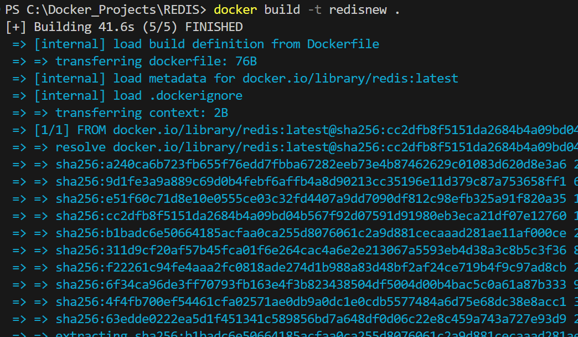
2. docker run --name myredisnew -d redisnew
What it does:
• Starts a new container (mini computer) from the redisnew image.
• --name myredisnew: Names the container "myredisnew" so it’s easy to identify.
• -d: Runs the container in the background.

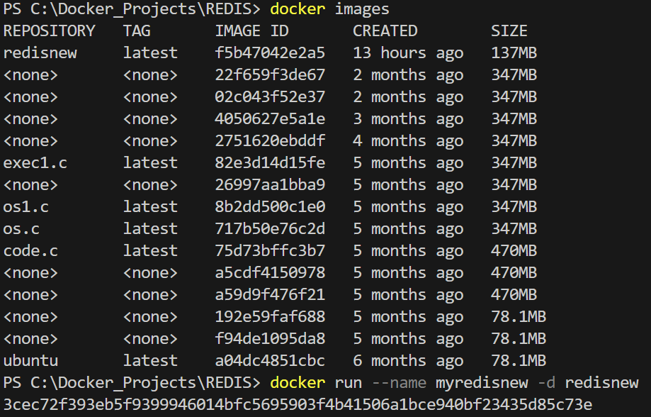

3. docker ps
What it does:
• Shows a list of containers that are running right now.
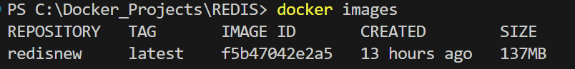
5. docker login
What it does:
• Logs you into your Docker Hub account, so you can upload images.

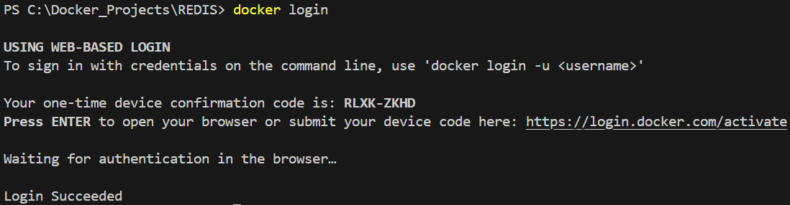

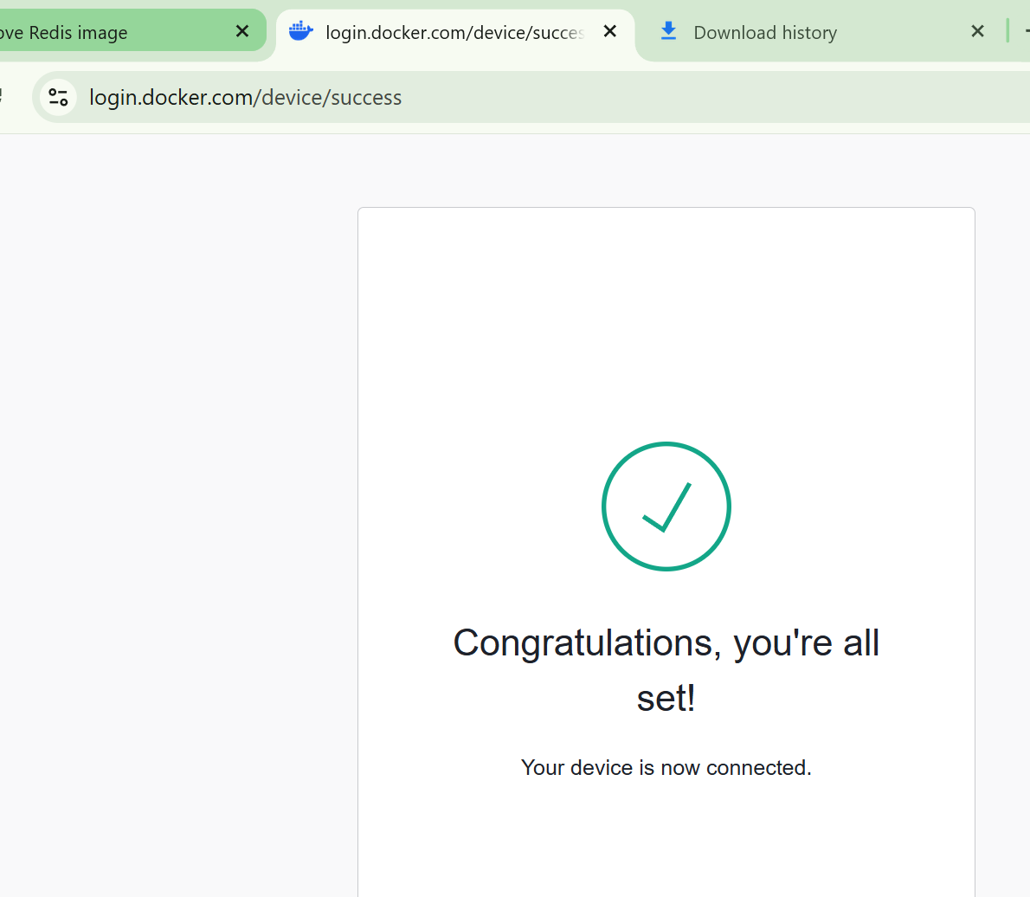

6. docker ps -a
What it does:
• Shows a list of all containers, including stopped ones.

7. docker commit 0e993d2009a1 budarajumadhurika/redis1
8. docker images

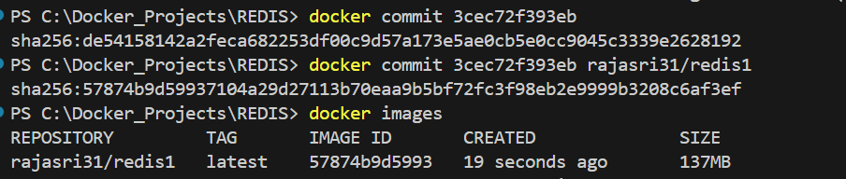

9. docker push budarajumadhurika/redis1
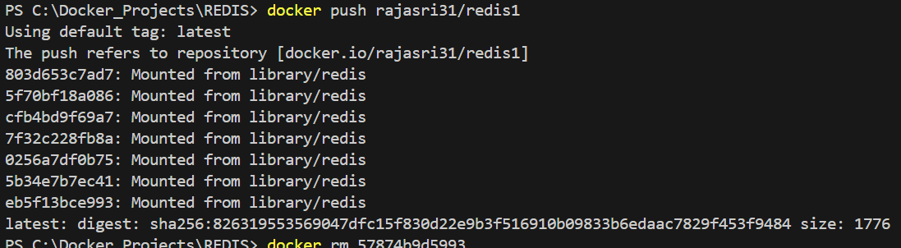
10. docker rm 0e993d2009a1
What it does:
• Deletes the container with ID 0e993d2009a1.

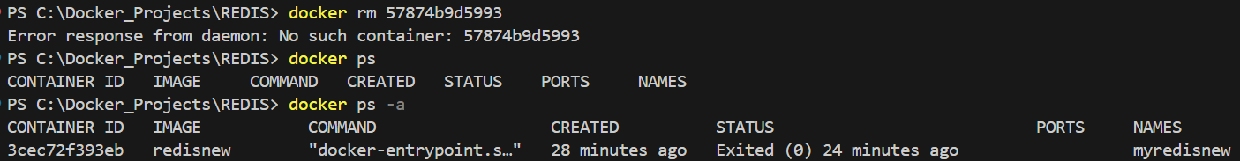

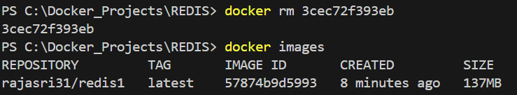
11. docker rmi budarajumadhurika/redis1
What it does:
• Deletes the image budarajumadhurika/redis1 from your system.

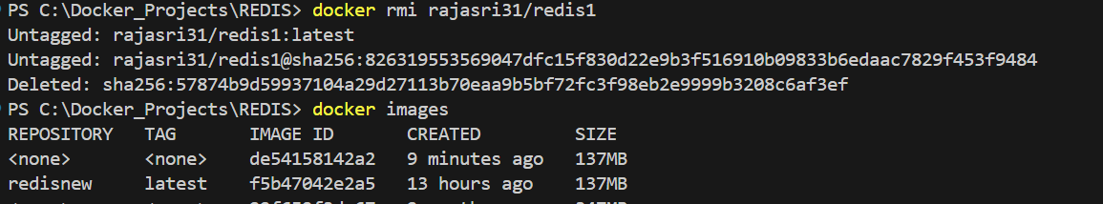
13. docker logout
What it does:
• Logs you out of Docker Hub.

14. docker pull budarajumadhurika/redis1
What it does:
• Downloads the image budarajumadhurika/redis1 from Docker Hub.
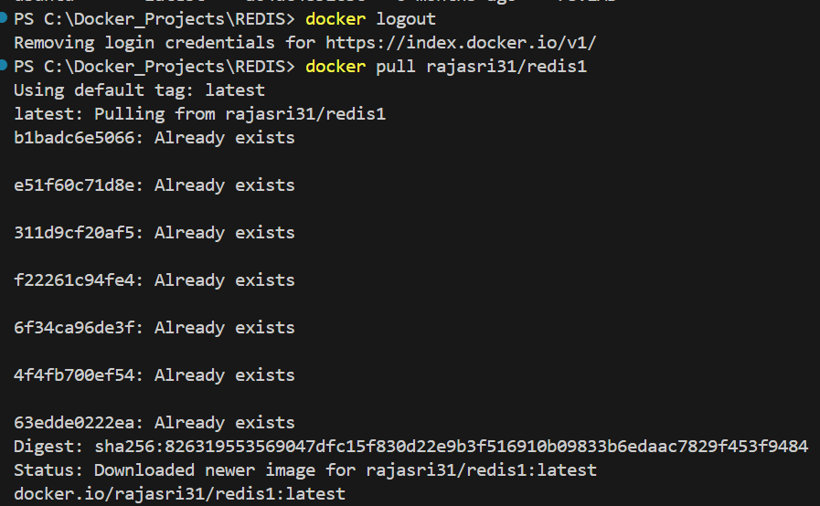
15. docker run --name myredis -d budarajumadhurika/redis1
What it does:
• Starts a new container using the image budarajumadhurika/redis1.

16. docker exec -it myredis redis-cli
What it does:
• Opens the Redis command-line interface (like a terminal) inside the running container
myredis.
17. SET name "Abcdef"
What it does:
• Saves a key-value pair in Redis (key = name, value = Abcdef).
18. GET name
What it does:
• Retrieves the value of the key name from Redis (it will return "Abcdef").
19. exit

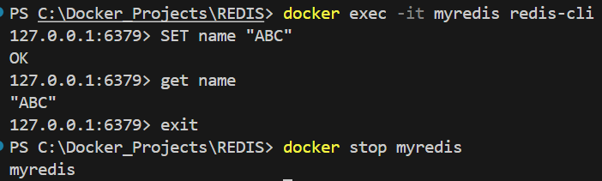
22. docker rm 50a6e4a9c326
What it does:
• Deletes the container with ID 50a6e4a9c326.
23. docker images
What it does:
• Lists all images again to confirm which ones remain.
24. docker rmi budarajumadhurika/redis1


